Weekly reports are to be emailed to atbecker@uh.edu by 5:00pm on Tuesdays. The purpose of a weekly report is to: (1) give you text and images for your papers, thesis, and dissertation, (2) document progress, (3) identify if you are stuck or need resources.

Weekly report

1. **My *Goals* from last week**
   * Make 5x5 Tilt Table work more efficiently.
   * Make passive sliders and stop blocks that work better with 5x5 Tilt Table.
2. **My *Accomplishments* this week**
   1. Project 1: <Learn to use 3D Printer>

* Two STL files, one that I created myself for use with the Kilobots (Kilobot Hexagon) and one file that I downloaded from Thingiverse.com to test the use of the 3D printer (balanced_die_version_2). <https://github.com/aabecker/LaserCutter3DPrinter/tree/master/LaserCutter/Designs/Jarrett%20Lonsford>
* 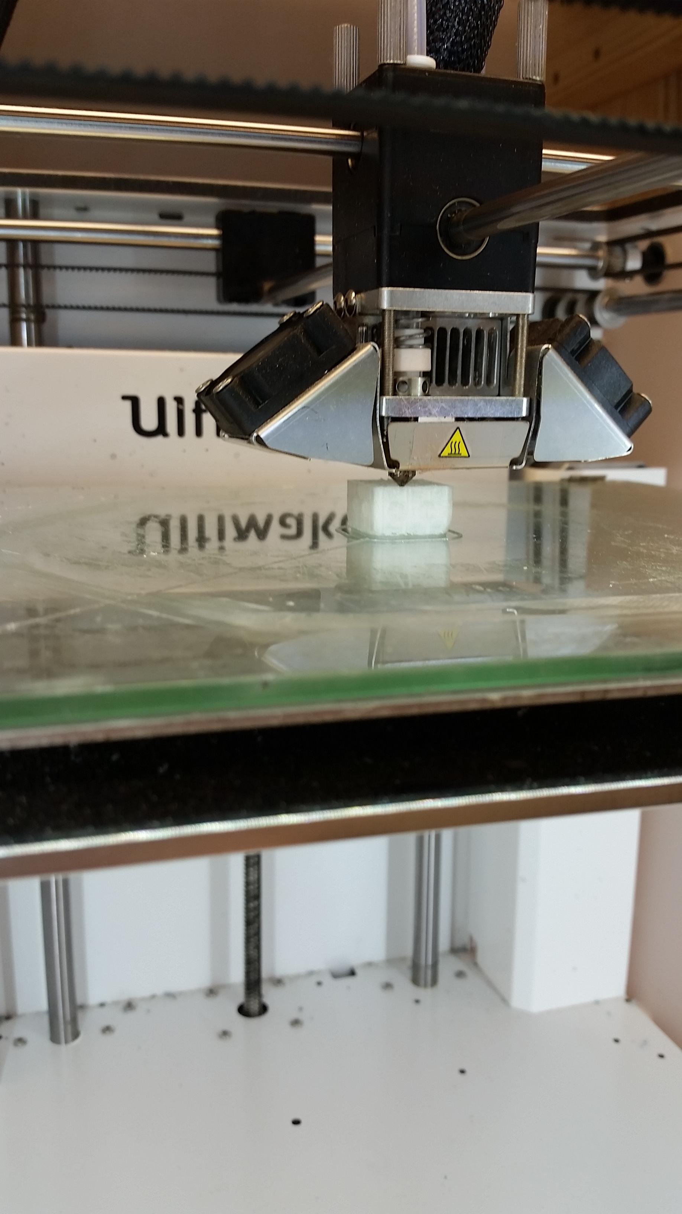

**Figure 1:** 3D printer printing the first of a pair of dice.

* 1. Project 2: <Passive Sliders>
     + DRW files used to cut passive sliders that house washers to increase weight. <https://github.com/aabecker/LaserCutter3DPrinter/blob/master/LaserCutter/Designs/Jarrett%20Lonsford/Slider_V1.dwg>
     + I tested a few different “weights” added to the existing round sliders to see if movement became smoother, after testing the additional weight of two washers I created four new sliders that could hold the washers within themselves to keep a low center of mass. The sliders were more successful than their predecessors, especially after sanding the bottom edges to increase ease of movement.

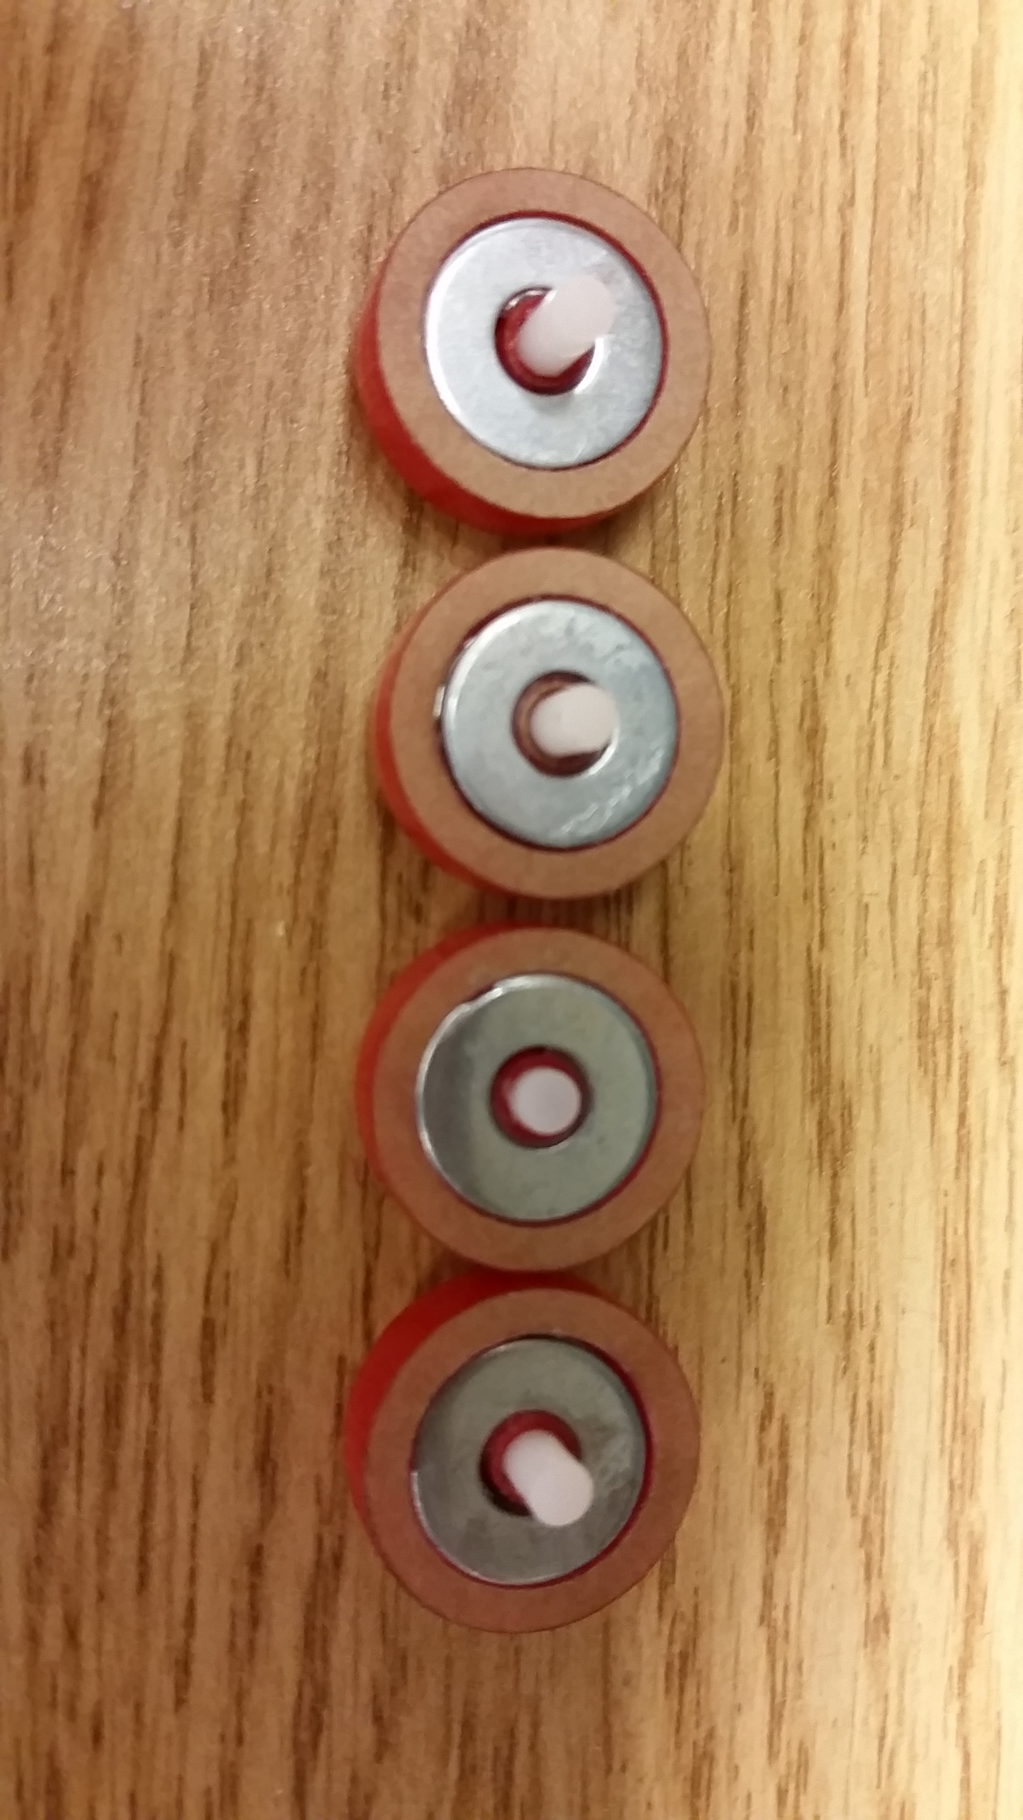

**Figure 2:** Four weighted sliders.

* 1. Project 3: <AND Gate Tilt Table>
     + DRW files used to cut a 15x9 table from the laser cutter. <https://github.com/aabecker/LaserCutter3DPrinter/tree/master/LaserCutter/Designs/Jarrett%20Lonsford/15_by_9_and_gate.dwg>
     + I tested several things using the 5 by 5 rasted tilt table and a couple of test cuts to ensure the success of the larger table. The first thing I tested was whether placing holes in the tilt table for the stop blocks would keep the sliders from knocking them off. I tested this by drilling holes into the existing table and it seemed to work, so I then cut a 3 by 3 test board with holes for stop blocks. With this test the stop blocks fit and stayed in place very well but the laser cutter also burned the sides of the slider tracks when cutting the holes as the tolerance was too small. This caused the sliders to get caught in the tracks, so I fixed this by increasing the width of the track and tested it with a small 1 by 2 board. This was a success on all accounts and gave me a final plan for the large board. I also adjusted the fillet on the corners of the slider track to keep the sliders from veering into a cross path. I adjusted the original 0.4 cm radius to 0.2 cm and this was tested on the 3 by 3 and 1 by 2 boards. The board is almost complete, I am still working on the assembling the stop blocks in order to make the functioning AND Gate but the board works well thus far.

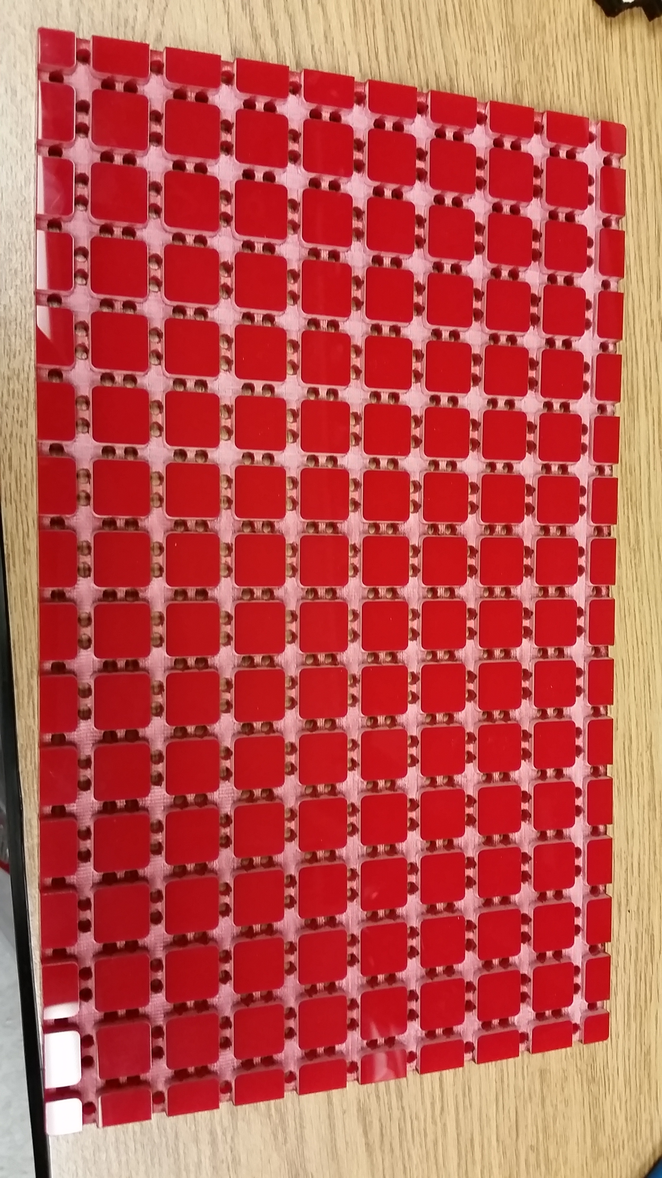

**Figure 3:** 15x9 table that will be used to complete the AND Gate demo.

* 1. Project 4: <Stop Blocks>
     + DRW files used to cut Stop Blocks. <https://github.com/aabecker/LaserCutter3DPrinter/blob/master/LaserCutter/Designs/Jarrett%20Lonsford/Stop_Block_V2.dwg>
     + The stop blocks work great now that they fit inside of the tilt table, I just might not have enough long plastic dowel rods to complete the AND Gate setup. The shorter dowel rods still work, just not as well as it could cause the stop blocks to come loose if hit hard enough.



**Figure 4:** Very blurry stop block that fits into holes on the 15x9 board (my camera refused to focus, sorry).

1. **My *Goals* for next week**

* Test ways to mount servo motors to tilt table.
* Learn how to control tilt table with MATLAB.
* Test ideas for magnetic mating sliders.
* Make 2x1 passive sliders.

1. **What I need Dr. Becker to do:**
   1. Purchase at least two more packs of 50 plastic dowel rods (1/8 inch diameter).
   2. Be on the lookout for a purchase request for servo motors.